Project Planning Phase
Project Planning Template (Product Backlog, Sprint Planning, Stories, Story points)

Date | 30 September 2026
Team ID | SWTID-2026-7743
Project Name | AI FAQ Assistant API
Maximum Marks | 5 Marks

Product Backlog, Sprint Schedule, and Estimation (4 Marks)
Use the below template to create product backlog and sprint schedule
Sprint | Functional Requirement (Epic) | User Story Number | User Story / Task | Story Points | Priority | Team Members
Sprint-1 | Project Setup & Authentication | USN-1 | As a developer, I can set up the FastAPI project with Docker and a common repository structure. | 2 | High
Sprint-1 |  | USN-2 | As an administrator, I can register my organisation with email and password and receive an API key. | 3 | High
Sprint-1 |  | USN-3 | As an administrator, I can log in to the dashboard using email and password. | 3 | High
Sprint-1 | FAQ Ingestion | USN-4 | As an administrator, I can upload FAQs as CSV or JSON files. | 5 | High
Sprint-1 |  | USN-5 | As an administrator, I can upload PDF documents whose text is extracted and split into chunks. | 5 | Medium
Sprint-1 |  | USN-6 | As the system, I convert FAQ chunks into embeddings and store them in the vector database. | 2 | High
Sprint-2 | Question Answering | USN-7 | As a user, I can send a question to POST /v1/ask and receive an answer. | 5 | High
Sprint-2 |  | USN-8 | As a user, I receive answers generated only from the most relevant FAQ content. | 5 | High
Sprint-2 | Answer Reliability | USN-9 | As a user, I can see the source FAQ for every answer. | 3 | High
Sprint-2 |  | USN-10 | As a user, I get an "I don't know / contact support" reply when confidence is low. | 3 | High
Sprint-2 | Performance & Validation | USN-11 | As a developer, repeated questions are served from the Redis cache. | 2 | Medium
Sprint-2 |  | USN-12 | As a developer, invalid or empty requests return clear error messages. | 2 | Medium
Sprint-3 | FAQ Management | USN-13 | As an administrator, I can view, edit and delete FAQs. | 5 | High
Sprint-3 | Feedback & Analytics | USN-14 | As a user, I can give thumbs up / down feedback on an answer. | 2 | Medium
Sprint-3 |  | USN-15 | As an administrator, I can see top questions and unanswered questions. | 5 | Medium
Sprint-3 | API Access Control | USN-16 | As an administrator, I can revoke keys and the API applies rate limiting per key. | 3 | High
Sprint-3 | Multilingual Support | USN-17 | As a user, I can ask in Tamil or Hindi and get the answer in the same language. | 5 | Medium
Sprint-4 | Integration | USN-18 | As a business, I can embed a chat widget on my website with a few lines of code. | 5 | Medium
Sprint-4 | Documentation | USN-19 | As a developer, I can read complete API documentation (Swagger UI and README). | 2 | Medium
Sprint-4 | Testing & Quality | USN-20 | As a team, we run unit, integration and load tests on the API. | 5 | High
Sprint-4 |  | USN-21 | As a team, we complete user acceptance testing and fix reported bugs. | 3 | High
Sprint-4 | Deployment | USN-22 | As a team, we deploy the application to the cloud with a CI/CD pipeline. | 5 | High

Project Tracker, Velocity & Burndown Chart: (4 Marks)
Sprint | Total Story Points | Duration | Sprint Start Date | Sprint End Date (Planned) | Story Points Completed (as on Planned End Date) | Sprint Release Date (Actual)
Sprint-1 | 20 | 6 Days | 05 Oct 2026 | 10 Oct 2026
Sprint-2 | 20 | 6 Days | 12 Oct 2026 | 17 Oct 2026
Sprint-3 | 20 | 6 Days | 19 Oct 2026 | 24 Oct 2026
Sprint-4 | 20 | 6 Days | 26 Oct 2026 | 31 Oct 2026

Velocity:
Our sprint duration is 6 days and the team velocity is 20 story points per sprint (80 story points across 4 sprints). Average velocity (AV) per iteration unit = velocity ÷ sprint duration = 20 ÷ 6 = 3.33 story points per day.

Burndown Chart:
A burn down chart is a graphical representation of work left to do versus time. It is often used in agile software development methodologies such as Scrum. However, burn down charts can be applied to any project containing measurable progress over time.
Planned burndown for the AI FAQ Assistant API (80 story points over 4 sprints). Actual progress will be added to the chart after each sprint.
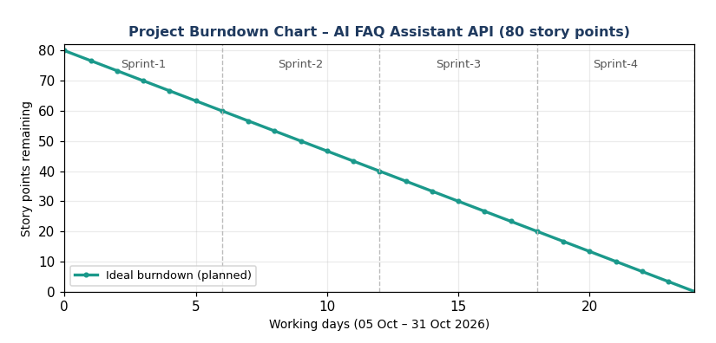

https://www.visual-paradigm.com/scrum/scrum-burndown-chart/
https://www.atlassian.com/agile/tutorials/burndown-charts

Reference:
https://www.atlassian.com/agile/project-management
https://www.atlassian.com/agile/tutorials/how-to-do-scrum-with-jira-software
https://www.atlassian.com/agile/tutorials/epics
https://www.atlassian.com/agile/tutorials/sprints
https://www.atlassian.com/agile/project-management/estimation
https://www.atlassian.com/agile/tutorials/burndown-charts

